**Create Database**

|  |  |
| --- | --- |
| Date | 16 Nov 2022 |
| Team ID | PNT2022TMID34450 |
| Project Name | Virtual Eye - Life Guard For Swimming Pools To Detect Active Drowning |

* In order to manage a connection from a local system you must first initialize the connection by constructing a Cloudant client.We need to import the cloudant library.

from cloudant.client import cloudant

* IBM Cloud Identity & Access Management enables you to securely authenticate users and control access to all cloud resources consistently in the IBM Bluemix Cloud Platform.

Client=cloudnt.iam(‘username’,’apikey’,connect=True)

In the above cloudant.iam() method we have to give username & apikey to build the connection with cloudant DB.

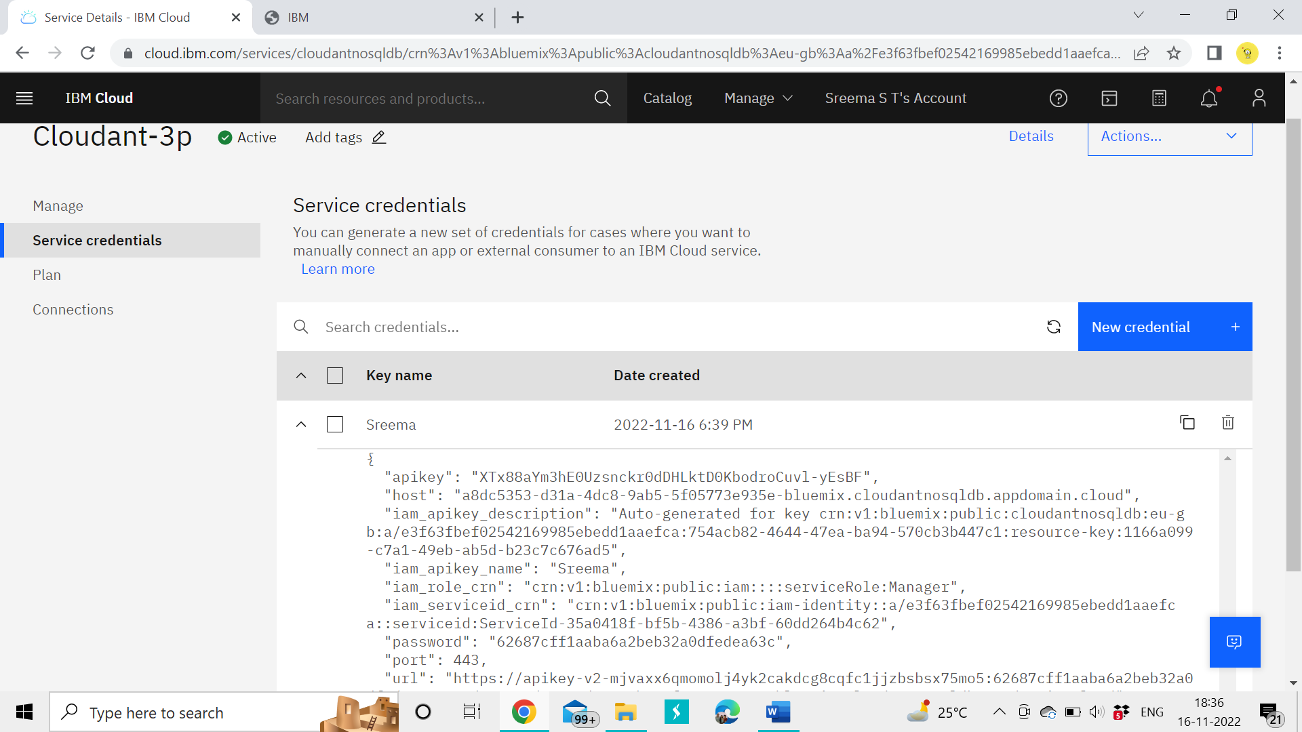

* Once a connection is established you can then create a database, open an existing database.
* Create a database as my_database

m

y_database=

client.create_database(my_database’)

Same procedure followed by my team members

**Team ID:** PNT2022TMID34450

**Team Leader**: Jone Abutelin B

**Team Member1**: Femi Priya K.C

**Team Member2**: Sreema S.T

**Team Member3**: Suthi R